**HACKATHON 2k19**

**Application Name: STEP** (Solution To Every problem)

**Platform Requirement:** Android

**User Guide STEP Application:**

**Step 1:** Install this app from provided link.



**Step 2**: Firstlygive location access permission. (It is must to give location Access for proper functionality of App)

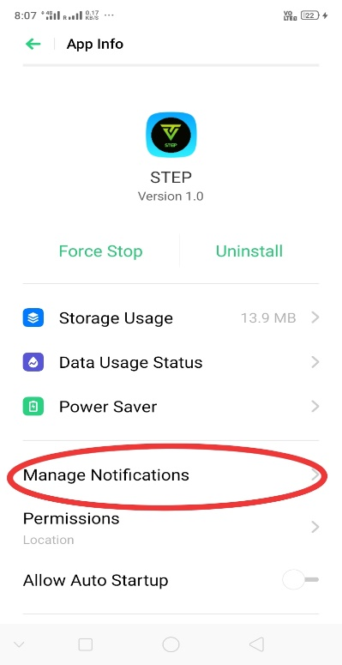

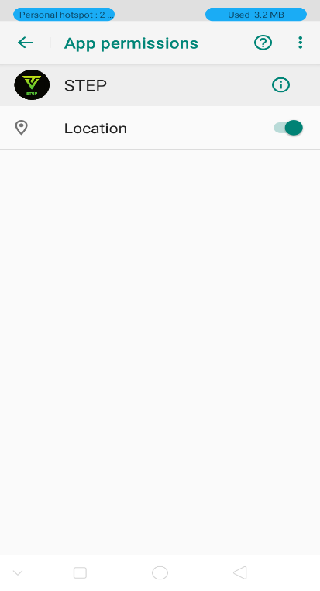

**Step 3:** launch the Application from your application menu *(first Page Appear like as below):*

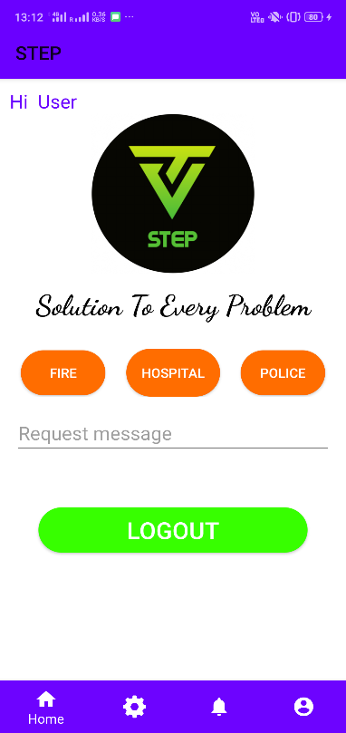

**Step 4:** If you are not logged in or new user then click on login/Sign_up button in menu bar.

* If you are an Existing user then put correct credential and click on **lOGIN** button.
* If you are new user then click on **CREATE ACCOUNT** button and which take you to signup page where you fill all required details and click on **REGISTER** button to submit.

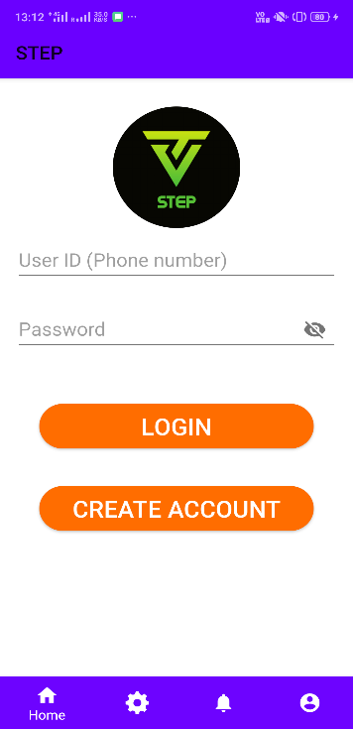 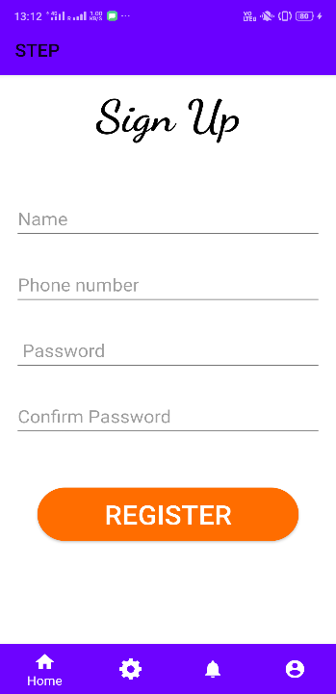

**Step 5:** After registeration process is done successfully move to login page and and login to application with correct credentials.

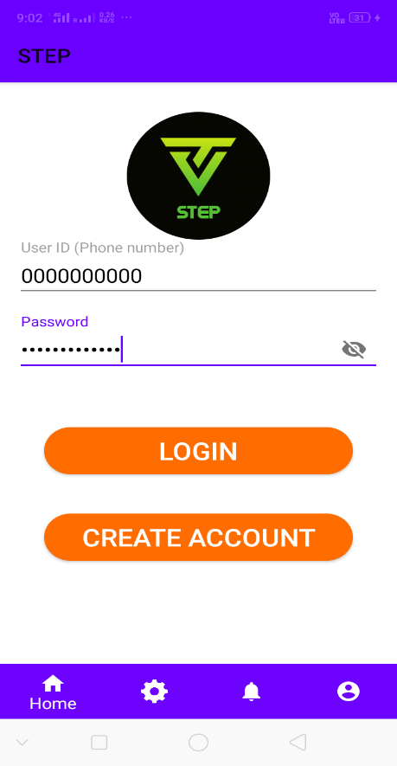 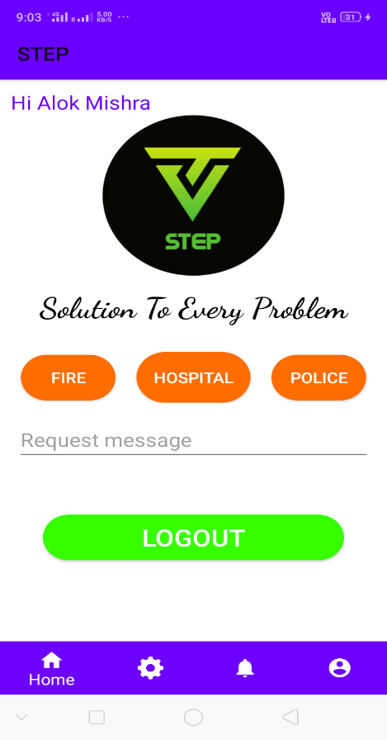

**Step 6:** After this go to setting menu and pinned your location (as this is your permanent location).

(**Note:** Alert settings and Add contacts are not functional at present. At Present Only Add location button is functional which take you to map page where you can add Locations where others can reach you when the need help)

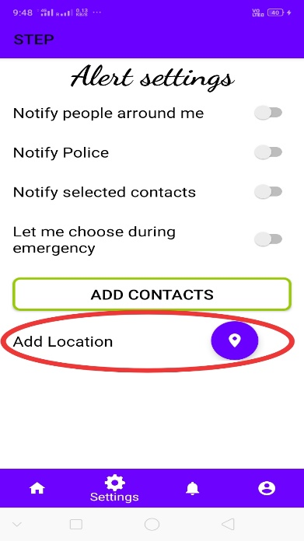 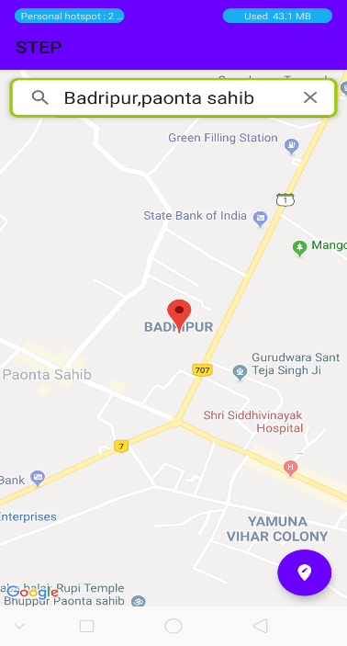

Save your location

Search for Location

**Step 7:** After completion of all these steps in two or more Android Smartphones now it’s time to make request from one phone by clicking the STEP button mentioned on home screen and also type your desired request message in message section. And then press the **STEP** button.

**(Note:** All the devices which are registered get notification but only condition is that they should be within 0.5 KM range of the person making the help request**)**

**Sometimes the notification is delayed depending on the processes running on device.**

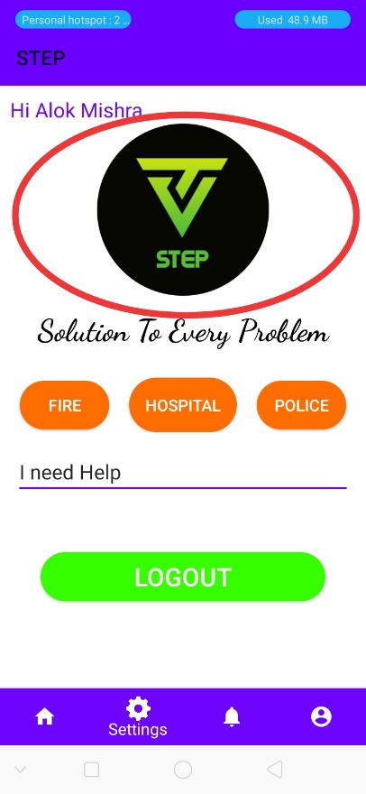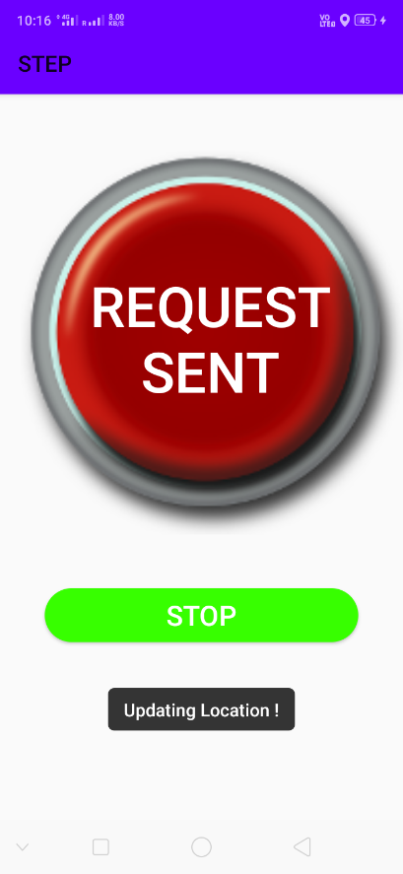 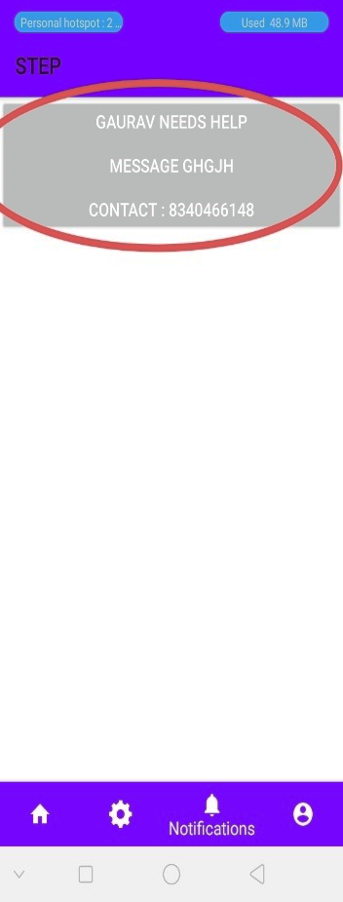

Type Help Message

here

Receiver

Sender

**Step 9:** After getting Notification if the person click on notification the application open the map page where live location is displayed and distance between them also displayed.

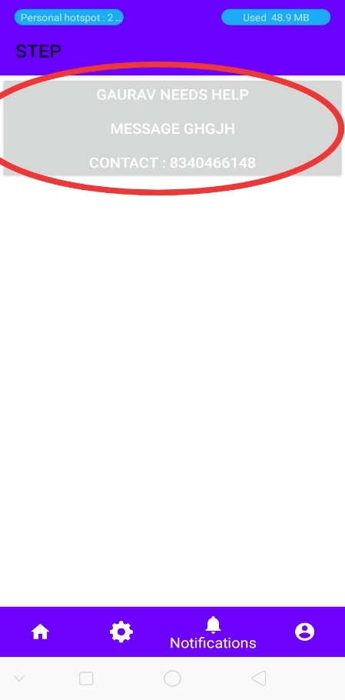 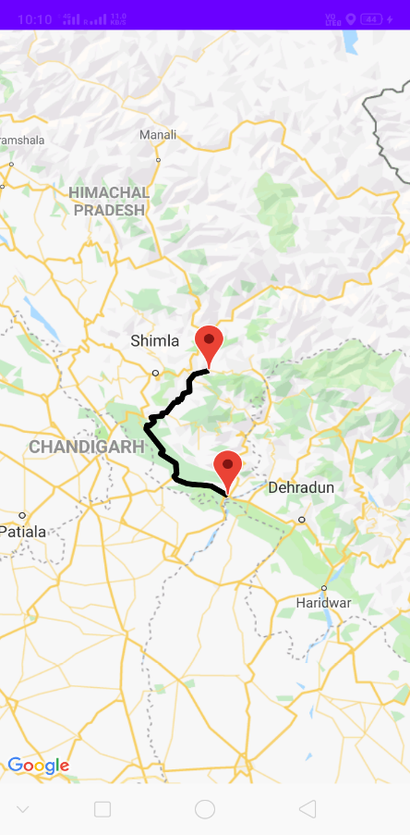

**Step 10:** Finally the live location tracking is started if person moves on any direction on map it is displayed. (Location is updated automatically ).